Honesty

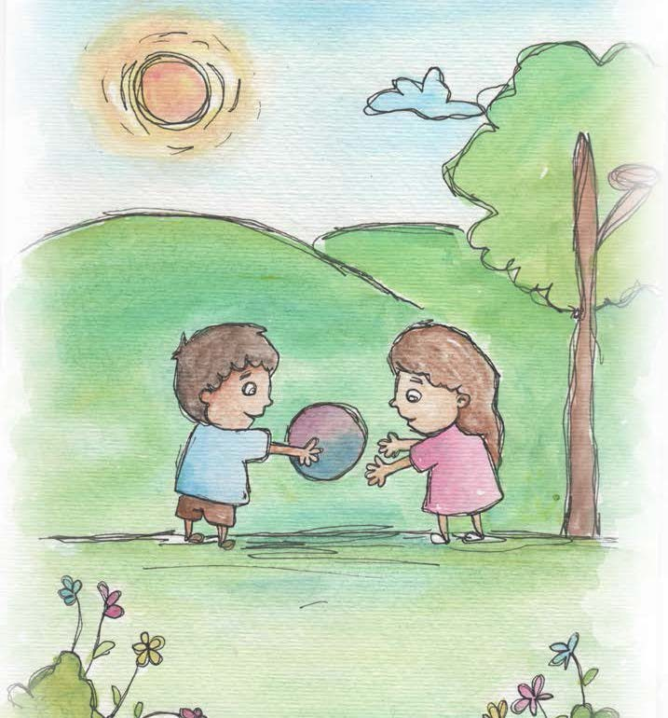

- Honesty is telling what really happened.

- Honesty is telling the truth.

- Honesty is when you don’t tell a lie, you don’t cheat.

- Honesty is keeping your promises.

- When I feel honest, I feel clear inside.

- When I am honest, I can learn and help others learn to be giving.
- The heart of honesty is fairness.

- Honesty creates trust.

From Living Values Education Activities for Children Ages 3-7 years © 2019 Association for Living Values Education International - www.livingvalues.net

