Love

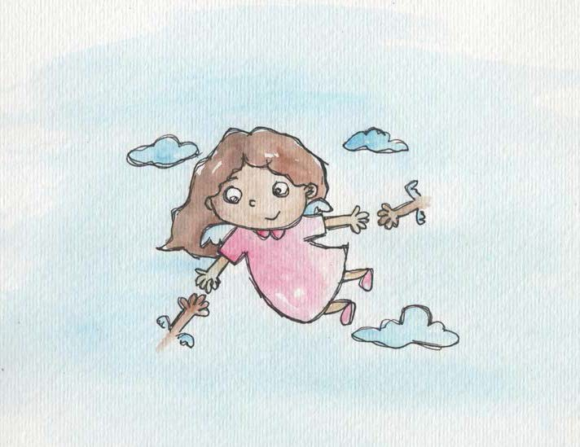

- Love is caring. Love is sharing.

- Love is being kind. I am good. I am love.
All children have love inside.

- We are always connected to everyone we love.

- Love means I want what is good for me.

- Love means I want what is good for others.

- Safe adults are loving and want what is good for me. Love makes me feel safe.
- When there’s lots of love inside, anger runs away.

From Living Values Education Activities for Children Ages 3-7 years
© 2019 Association for Living Values Education International - www.livingvalues.net

