Tolerance

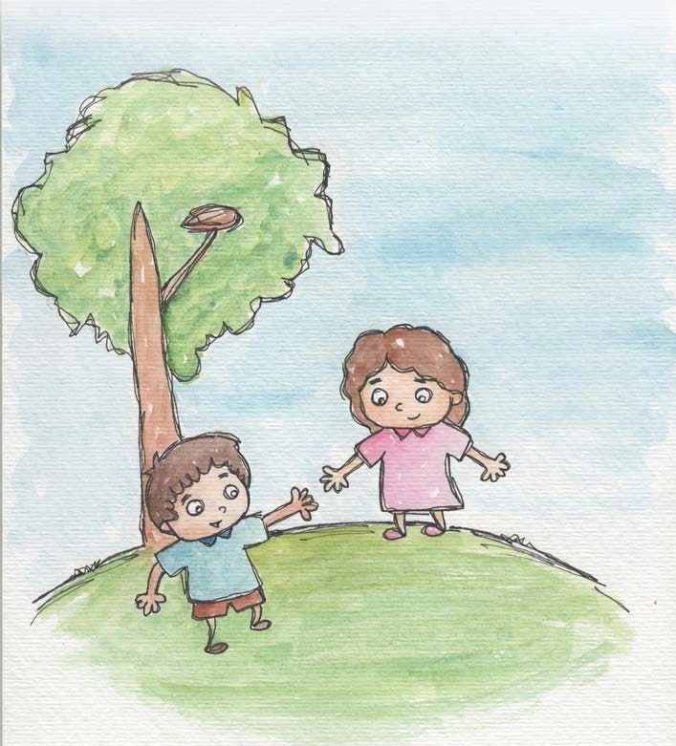
- We are all unique and have something valuable to offer and share.
- Tolerance is appreciating differences.

- Tolerance is being open to everyone’s beauty.

- Tolerance is respecting each other’s culture.

- Tolerance grows with respect and understanding. Love for all others grows tolerance. We are all part of one human family.

- Tolerance is accepting others and myself, when even I make mistakes.


From Living Values Education Activities for Children Ages 3-7 years © 2019 Association for Living Values Education International - www.livingvalues.net

