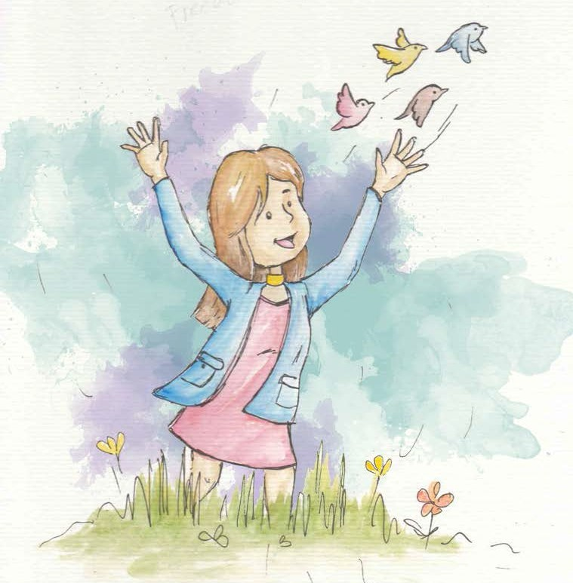
Freedom

Freedom resides within the mind and heart.
Freedom is a precious gift.

There can be full freedom when rights are balanced with responsibilities.

There is full freedom when everyone has equal rights.

All people have a right to be free.
For all to be free, each one has to respect the rights of others.

Inner freedom is experienced when I have positive thoughts for all, including myself.


From Living Values Education Activities for Children Ages 8-14 years © 2019
Association for Living Values Education International - www.livingvalues.net

