Peace

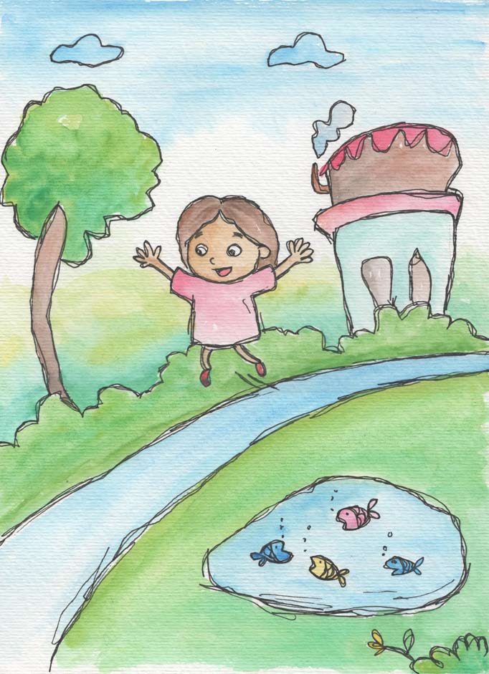
- Peace is being quiet inside.
- Peace is having good feelings inside.
- Peace is feeling relaxed and safe.
- Peace is when people get along and
don’t argue or hit.
- Peace is having positive thoughts for myself and others.
- Peace begins within each one of us.


From Living Values Education Activities for Children Ages 8-14 years © 2019
Association for Living Values Education International - www.livingvalues.net

