Happiness

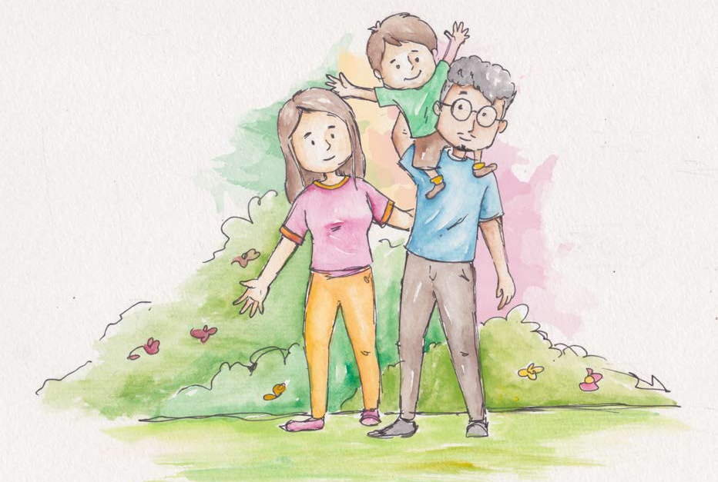
When I have love and peace inside, happiness just comes.

Happiness is a state of peace in which there is no upheaval or violence.

When there is a feeling of hope, there is happiness.
Good wishes for everyone give happiness inside.
Happiness naturally comes with pure and selfless actions.

When one is content with oneself, happiness comes automatically.
When my words express ‘give flowers instead of thorns,’ I create a happier world.


From Living Values Education Activities for Young Adults © 2019
Association for Living Values Education International - www.livingvalues.net

