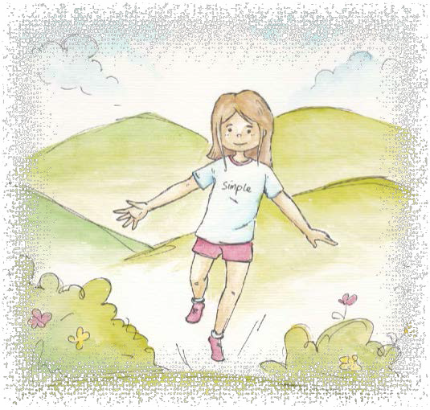

Simplicity is natural. Simplicity is being natural.

Simplicity is learning from the earth.

Simplicity is staying in the present and not making things complicated.

Simplicity is enjoying a plain mind and intellect. Simplicity teaches us economy—how to use our resources wisely, keeping future generations in mind.

Simplicity is appreciating the small things in life.

From LivingValuesActivities for Young Adults.© 2019 Association for Living Values Education International - www.livingvalues.net

